**Ideation Phase**

**Define the Problem Statements**

|  |  |
| --- | --- |
| Date | 19 September 2022 |
| Team ID | PNT2022TMID31650 |
| Project Name | Project – Crude Oil Price Prediction |
| Maximum Marks | 2 Marks |

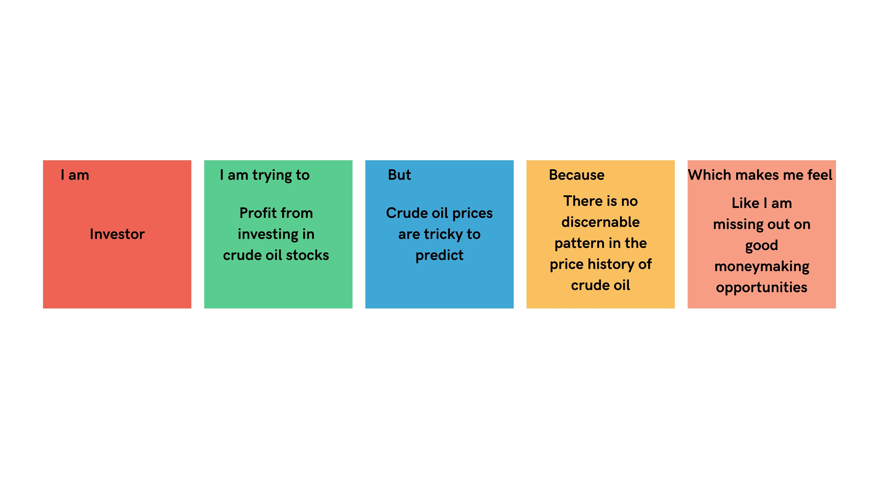

|  |  |  |  |  |  |
| --- | --- | --- | --- | --- | --- |
| **Problem Statement (PS)** | **I am** | **I’m trying to** | **But** | **Because** | **Which makes me feel** |
| PS-1 | Investor | Profit from investing in crude oil stocks | Crude oil prices are tricky to predict | There is no discernable pattern in the price history of crude oil | Like I am missing out on good moneymaking opportunities. |